 | Ext. | Email
Tuition Fee Waiver (Dependent Verification)
MyUWF – Employee Resources, Employee Tuition Waiver
Elsie Rivera | 2921 | erivera@uwf.edu
Tony Lindberg | 2610 | tlindber@uwf.edu
Adrian Rowley | 2604 | arowley@uwf.edu
Unemployment
April Harvey | 2694 | aharvey@uwf.edu
Jamie Sprague | 2156 | jsprague@uwf.edu
Union Contract Administration
Jamie Sprague | 2156 | jsprague@uwf.edu
Volunteer Program
Anna Isfalt | 2233 | asfalt@uwf.edu
April Harvey | 2694 | aharvey@uwf.edu
W-2
MyUWF, Employee Self Service, (Banner) Tax Forms,
Payroll (Financial Services) | 3051
W-4 (New Employees Only)
Christine N. Dillard | 2508 | cniemann@uwf.edu
Nicole Zamary | 2608 | nzamary@uwf.edu
Deborah Baker | 2605 | dbaker@uwf.edu
Lori Werdann | 2205 | lwerdann@uwf.edu
W-4 (Changes)
Payroll (Financial Services) | 3051
Workers’ Compensation
April Harvey | 2694 | aharvey@uwf.edu
 | Ext. | Email
Position Orientation Year (Extension)
Lynne Randall | 2292 | lrandall1@uwf.edu
Jamie Sprague | 2156 | jsprague@uwf.edu
Records
Christine N. Dillard | 2508 | cniemann@uwf.edu
Nicole Zamary | 2608 | nzamary@uwf.edu
Lori Werdann | 2205 | lwerdann@uwf.edu
Recruitment
Kris Keating | 2601 | kkeating@uwf.edu
April Harvey | 2694 | aharvey@uwf.edu
Anna Isfalt | 2233 | asfalt@uwf.edu
Research Integrity Coordinator
Gabriel Esmurdoc | 2260 | gesmurdoc@uwf.edu
Retirement and DROP
Tony Lindberg | 2610 | tlindberg@uwf.edu
Jamie Sprague | 2156 | jsprague@uwf.edu
Elsie Rivera | 2921 | erivera@uwf.edu
Adrian Rowley | 2604 | arowley@uwf.edu
Separation Clearance
Nicole Zamary | 2608 | nzamary@uwf.edu
Christine N. Dillard | 2508 | cniemann@uwf.edu
Service & Retirement Awards
Candace Freeman | 2602 | cfreeman@uwf.edu
Sick Leave Pool
Tony Lindberg | 2610 | tlindberg@uwf.edu
Jamie Sprague | 2516 | jsprague@uwf.edu
Elsie Rivera | 2921 | erivera@uwf.edu
Staff Development / Training
Lynne Randall | 2292 | lrandall1@uwf.edu
Termination
Jamie Sprague | 2156 | jsprague@uwf.edu
Time and Leave Reporting/Effort Recaps
Nicole Zamary | 2608 | nzamary@uwf.edu
Christine N. Dillard | 2508 | cniemann@uwf.edu
Tony Lindberg | 2610 | tlindberg@uwf.edu
Jamie Sprague | 2156 | jsprague@uwf.edu
Training Class Registration
Lynne Randall | 2292 | lrandall1@uwf.edu
Human Resources

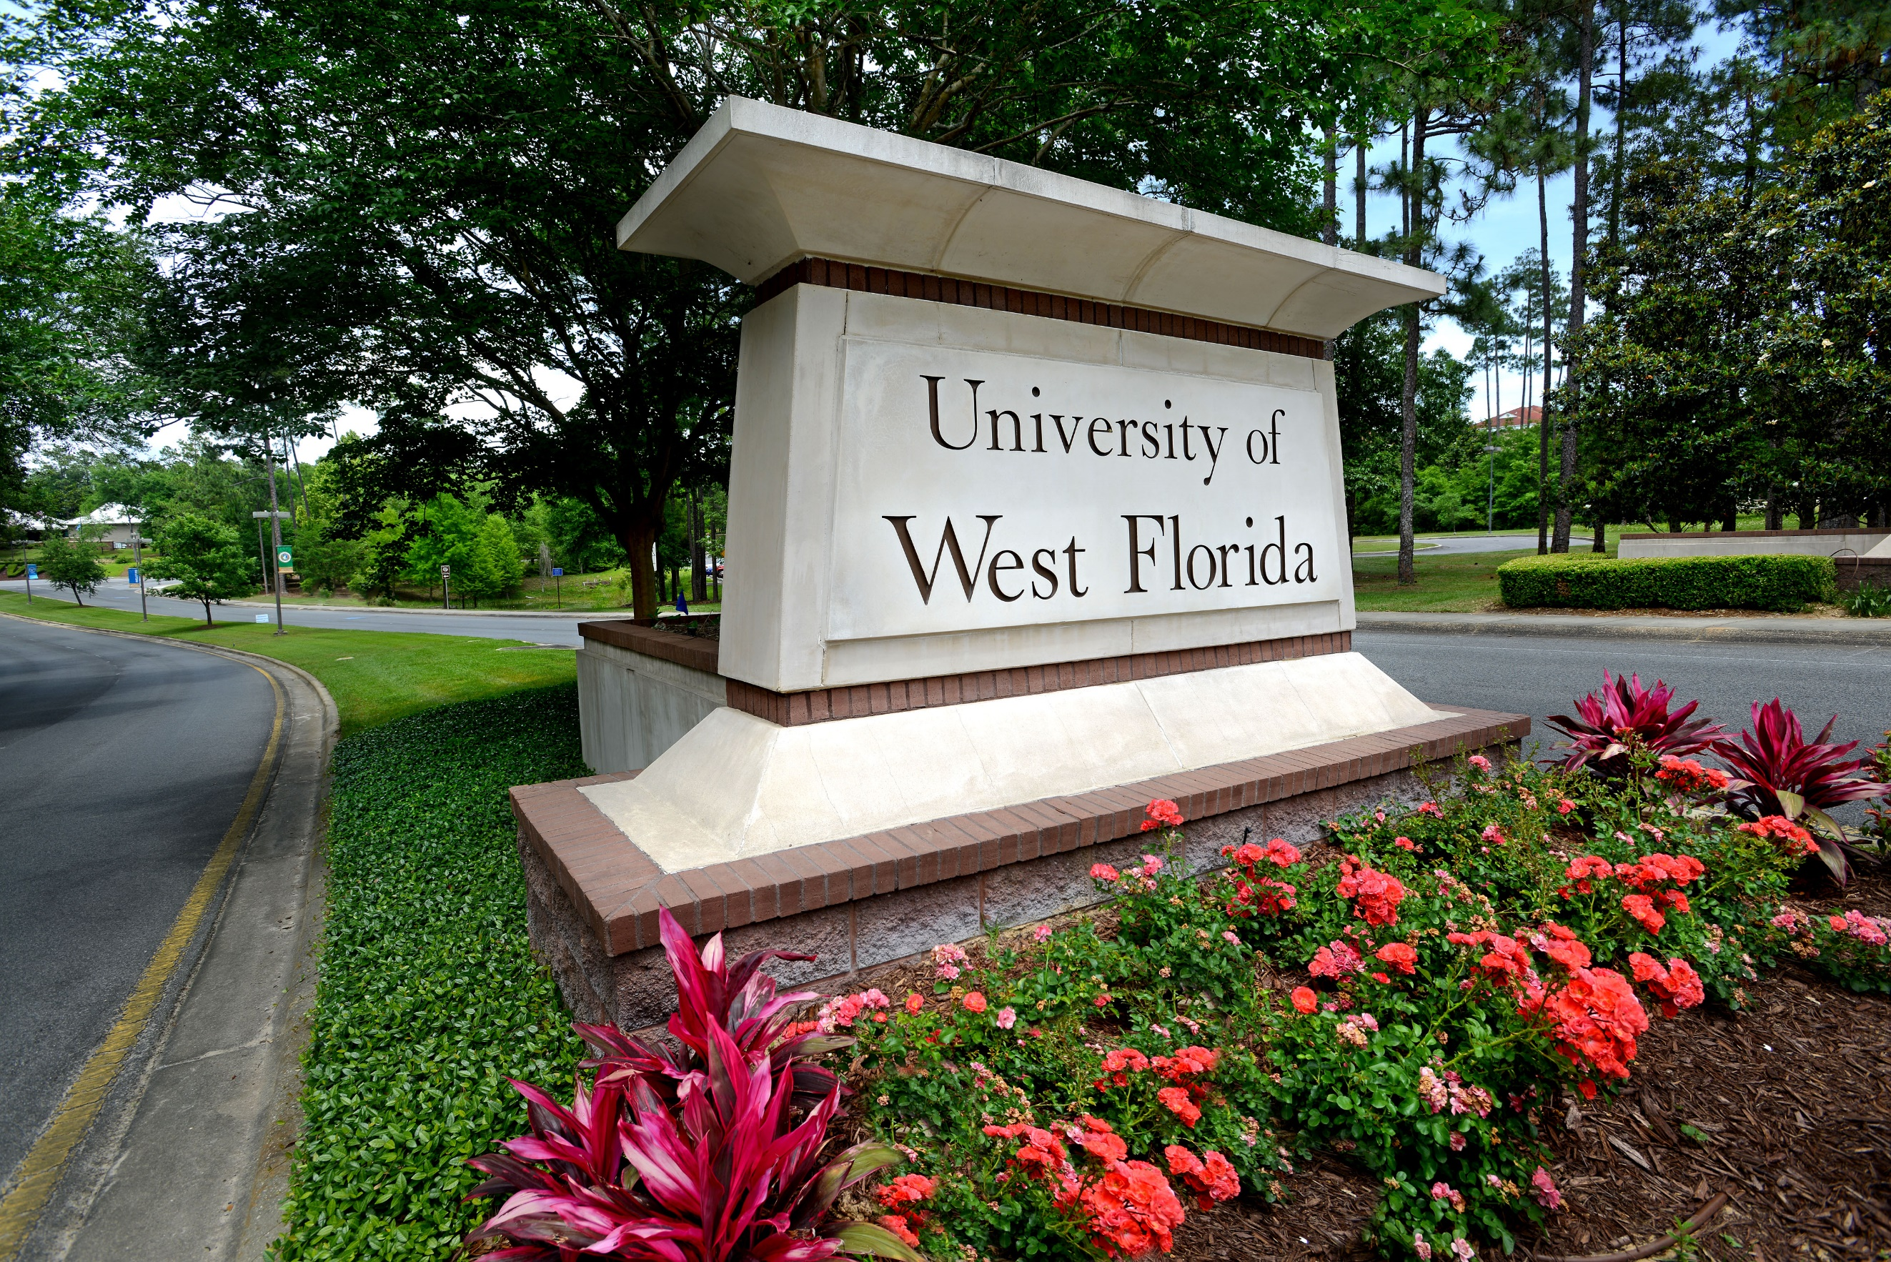

Mission Statement
To provide vital and innovative programs that result in the employment and retention of a diverse and high-quality workforce dedicated to student success.

Revised: April 11, 2024

Who to Call

UWF is an Equal Opportunity/Access/
Affirmative Action/Disabled/Veteran Employer
11000 University Parkway
Building 20E, Room 117
Pensacola, FL 32514
Phone: 850.474.2694
Fax: 850.857.6030
hr@uwf.edu
uwf.edu/hr
 | Ext. | Email
Americans with Disabilities Act (ADA)
April Harvey | 2694 | aharvey@uwf.edu
Jamie Sprague | 2156 | jsprague@uwf.edu
Annuities
Tony Lindberg | 2610 | tlindberg@uwf.edu
Adrian Rowley | 2604 | arowley@uwf.edu
Elsie Rivera | 2921 | erivera@uwf.edu
Background Screenings
Grace Giddens | 3481 | ggiddens@uwf.edu
April Harvey | 2694 | aharvey@uwf.edu
Level 2 Background Screening
Grace Giddens | 3481 | ggiddens@uwf.edu
April Harvey | 2694 | aharvey@uwf.edu
Benefits
Adrian Rowley | 2604 | arowley@uwf.edu
Elsie Rivera | 2921 | erivera@uwf.edu
Tony Lindberg | 2610 | tlindberg@uwf.edu
Change of Address (Home and Campus)
My UWF - Employee Self-Service (all services)
Nicole Zamary | 2608 | nzamary@uwf.edu
Christine Dillard | 2508 | cniemann@uwf.edu
Disciplinary Actions (Staff)
Lynne Randall | 2292 | lrandall1@uwf.edu
Jamie Sprague | 2156 | jsprague@uwf.edu
Disciplinary Actions (Faculty)
Jamie Sprague | 2156 | jsprague@uwf.edu
Educational Leave with Pay
Tony Lindberg | 2610 | tlindberg@uwf.edu
Jamie Sprague | 2156 | jsprague@uwf.edu
Employee Assistance Program
Lynne Randall | 2292 | lrandall1@uwf.edu
Jamie Sprague | 2156 | jsprague@uwf.edu
Employment Contracts (Faculty)
Christine N. Dillard | 2508 | cniemann@uwf.edu
Employment Exit Interviews
Lynne Randall | 2292 | lrandall1@uwf.edu
Jamie Sprague | 2156 | jsprague@uwf.edu
Employee Relations
Lynne Randall | 2292 | lrandall1@uwf.edu
Jamie Sprague | 2156 | jsprague@uwf.edu
 | Ext. | Email
Mediation/Conflict Resolution
Lynne Randall | 2292 | lrandall1@uwf.edu
Jamie Sprague | 2156 | jsprague@uwf.edu
New Employee Payroll/Essential Documents
Christine N. Dillard | 2508 | cniemann@uwf.edu
Nicole Zamary | 2608 | nzamary@uwf.edu
Deborah Baker | 2605 | dbaker@uwf.edu
Lori Werdann | 2205 | lwerdann@uwf.edu
OPS Retirement Plan
Tony Lindberg | 2610 | tlindberg@uwf.edu
Elsie Rivera | 2921 | erivera@uwf.edu
Adrian Rowley | 2604 | arowley@uwf.edu
Organizational Chart
Anna Isfalt | 2233 | asfalt@uwf.edu
April Harvey | 2694 | aharvey@uwf.edu
Orientation, New Employees
Adrian Rowley | 2604 | arowley@uwf.edu
Elsie Rivera | 2921 | erivera@uwf.edu
Tony Lindberg | 2610 | tlindberg@uwf.edu
Outside Activity/Conflict of Interest
Jamie Sprague | 2156 | jsprague@uwf.edu
Overtime
Jamie Sprague | 2156 | jsprague@uwf.edu
Nicole Zamary | 2608 | nzamary@uwf.edu
Performance Evaluations
Lynne Randall | 2292 | lrandall1@uwf.edu
Jamie Sprague | 2156 | jsprague@uwf.edu
Performance Management (Needs Improvement/Below)
Lynne Randall | 2292 | lrandall1@uwf.edu
Jamie Sprague | 2156 | jsprague@uwf.edu
Personnel Action Forms (Staff, Faculty and Students)
Christine N. Dillard | 2508 | cniemann@uwf.edu
Nicole Zamary | 2608 | nzamary@uwf.edu
Deborah Baker | 2605 | dbaker@uwf.edu
Lori Werdann | 2205 | lwerdann@uwf.edu
Position Management/Job Classification/Job Description
Kris Keating | 2601 | kkeating@uwf.edu
April Harvey | 2694 | aharvey@uwf.edu

 | Ext. | Email
Employee Recognition and Awards Program (ERAP)
Lynne Randall | 2292 | lrandall1@uwf.edu
Jamie Sprague | 2156 | jsprague@uwf.edu
Employment Verification
Kris Keating | 2601 | kkeating@uwf.edu
April Harvey | 2694 | aharvey@uwf.edu
Equal Opportunity
Candace Freeman | 2602 | cfreeman@uwf.edu
FMLA/Medical Leave
Adrian Rowley | 2604 | arowley@uwf.edu
Tony Lindberg | 2610 | tlindberg@uwf.edu
Jamie Sprague | 2156 | jsprague@uwf.edu
Foreign National Employees–Temporary Work Visas
Christine N. Dillard | 2508 | cniemann@uwf.edu
Grievances
Jamie Sprague | 2156 | jsprague@uwf.edu
Holidays
Jamie Sprague | 2156 | jsprague@uwf.edu
Tony Lindberg | 2610 | tlindberg@uwf.edu
Christine N. Dillard | 2508 | cniemann@uwf.edu
I-9/E-Verify
Christine N. Dillard | 2508 | cniemann@uwf.edu
Nicole Zamary | 2608 | nzamary@uwf.edu
Deborah Baker | 2605 | dbaker@uwf.edu
Lori Werdann | 2205 | lwerdann@uwf.edu
Injuries (Work Related)
April Harvey | 2694 | aharvey@uwf.edu
Insurances
Adrian Rowley | 2604 | arowley@uwf.edu
Elsie Rivera | 2921 | erviera@uwf.edu
Tony Lindberg | 2610 | tlindberg@uwf.edu
Investments 403(b) and 457
Elsie Rivera | 2921 | erivera@uwf.edu
Adrian Rowley | 2604 | arowley@uwf.edu
Tony Lindberg | 2610 | tlindberg@uwf.edu
Layoff
Jamie Sprague | 2156 | jsprague@uwf.edu
Leave (non-medical)
Tony Lindberg | 2610 | tlindberg@uwf.edu
Jamie Sprague | 2156 | jsprague@uwf.edu
Elsie Rivera | 2921 | erivera@uwf.edu

UWF | Human Resources
uwf.edu/hr

