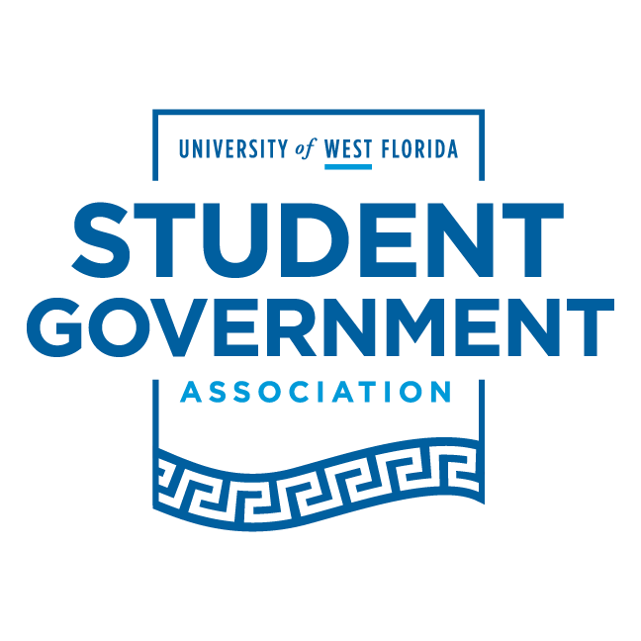

Resolution: 20-21 RS II

Author(s): Senator Matthew Arnold & Vice Chair Hoffman

To read as follows:

WHEREAS, President Negron joined the University of West Florida Student Government
Association as a freshman in the freshmen committee, starting his four years of service to the University and Student Body; and

WHEREAS, President Negron left a lasting impression on those in FC 2017-18, where he showed an aptitude to absorb knowledge and lead his peers with cooperation, kindness, and vigor; and

WHEREAS, President Negron showed resilience in the 51st​ ​ Senate as he took up the mantle as the Budgets and Allocations Chair and, with little experience, led his committee; wherein he affected the lives of many Argos and garnered the attention of many around the University; and

WHEREAS, President Negron served loyally to Governor Zenani D. Johnson as her Chief of Staff where he led state legislative initiatives, the executive branch, and initiatives to assist the student body in all aspects of their lives; and

WHEREAS, President Negron spearheaded a campaign to bring relief to Argonauts in need called Argos Assist, not only in a global pandemic but also admits the threat of natural disasters on our shores; and

WHEREAS, President Negron faithfully led the Student Government, advocated for Student Body needs, and held up the proper authority to model what a Student Body President should embody and highlighted the values that we as Argonauts carry in our every action.
THEREFORE, BE IT RESOLVED, on this twenty-third of October, at the regularly scheduled meeting of the 53​^{rd​} Senate that the University of West Florida Student Body hereby commends President Jordan V. Negron for his years of service to the Student Body, University of West Florida, and the Student Government Association and let him be forever honored as a true Argonaut.

___________________ ___________________
Mr. Jordan Negron Ms. Sydney Grant
Student Body President Senate Pro Tempore

